* (LIS-291) HIS Lab Order Report Inquiry (WIP),
  + Search by Lab No (Over-Write Auth DT, reference ) ref to Lab Order Inquiry
* (LIS-383) Add MT number at User Setting
  + SELECT MTNo,* FROM LISUser
  + Add MT No (Free text Box) between user name and Status
* (LIS-94) User Setting: Freeze the right-side box to stay in that position when moving the left-side box
* (LIS-401) Show service date & time in **patient search**
  + Quincy: Trim Patient Name & other text-input field
* (LIS-92) Add HKID number for search under the **patient log**,
* (LIS-426) Add and display Prefix for Test Code to ensure in-use or not
  + Add new field “TestCodePrefix (varchar(5) NULL)” (Text-input)
  + Please also prepare DB Script (SELECT * FROM dbo.ReferralLab rl)
* (LIS-104) Selection of specific referral laboratory for printing specific lab order sheet
  + UAT Sample: 99001022, 99000842
  + (1) Semi-Automatically print individual referral
  + (2) Selection of specific referral laboratory
  + Add “Print Label & Ref Lab Form” at the Label preview screen
  + Hide the referral-related buttons if there are no referral orders
  + One PDF, multi-page
  + Show Referral Lab English Name for selection
* (LIS-162) Add Sample Tracking in Patient Search screen (TEST Lab No.: 99001139)
  + Lab Order Sample Management -> Lab Order Detail -> Sample Tracking (Button)
* (LIS-167) Add Preview Label for printing labels in Billing screen (Rejected, already exist)
* (LIS-427) Order form with price debug
* (LIS-106) Format of Clinical Laboratory Order Form with Prices and Referral Laboratory Order Form
* (N/A) Add Instrument Code at Instrument Setting
* (N/A) PM2
* (LIS-164) All CAPITAL LETTERS in Surname and Given Name
* (LIS-88) Add patient name and room & bed under sample update
* (LIS-91) Re-locate closely to the Test Name and align the price to the right side
* (LIS-186) Let the user double-click from a list and also use the function key to choose comments
* (N/A) Visit Search (Test: PV20220500014)  
  Search by: Visit No (auto-redirect detail page), Patient No, Surname, Given Name, Chinese Name, DOB, ID No + Type  
  Function: Create / Edit LIS visit (PV…..) and LIS Patient (ID…….)  
   (New PV#/QAP) - Clean all input fields at the click  
   - Search for a Patient  
   - After selecting a patient, auto-fill all 'Patient Info'  
   - Copy all Patient Info fields to the 'Visit Info'  
   - User can modify the 'Visit Info' fields

- VisitNo/MotherVisitNo/VisitDT Cannot be changed

- They are blank during creation

- Create a New Visit

Output: Visit No, Patient No, Surname, Given Name, Chinese Name, ID No +Type  
Detail:

Update Mode + Create Mode

Edit Panel: "Edit" button, "Pat Log" v, "New PV#/QAP" button

Search back the freshly created/saved visit after creating/save

* (N/A) Order Search - Inquiry Screen
  + Search by: LabNo, VisitNo, VisitNo search helper, ServiceDT Range, OrderDoctorCode, SendReportTo, Test
  + Detail: LabNo, PV.visitNo, ServiceDT Range, Sample Collect DT, Patient Eng + Chi Name, ID, Sex, DOB
  + Sort by patient English name

* (LIS-445) Add "MTPart" at the user setting screen
  + ALTER TABLE LISUser
  + ADD MTPart tinyint NULL
* (LIS-350) Patient Search Bug
* (LIS-352) Patient Info - Remove validation
* (N/A) Add IdType at Patient Log (dynamically set HKID Card as default)
* (LIS-441) Add Visit Log  
  Search by Lag DT & User, VisitNo, PatientNo
* (LIS-412) Add alert message for patients who have MRSA, VRE, CRE history  
  -- Check Clin History; Can update?  
  -- Need to discuss with user and PW
* (LIS-444) Workgroup Setting: Freeze the right-side box to stay in that position when moving the left-side box
* (LIS-443) Ref Test Validation
* (LIS-442) Report Inquiry Log Enhancement (print as PDF/Excel buttons)
  + https://www.primefaces.org/primeng-v14-lts/table/export[PDF printing could exclude] IsUpdatedToHIS, IsAmendedReport, Status
* (LIS-253) Add "Send Report To" in patient search & patient details
* (LIS-257) Add returned class on Billing screen
* (LIS-449) Reg Note Bug: Unable to clear Reg note (screen + pop up box)
* (N/A) Rewrite usp_LIS_GET_LabOrderInquiry
* (N/A) Email notification for wrong input of security code.
* *(N/A) Add Organism Package Setting*
  + *Organism Statistics*
  + *SELECT \**
  + *FROM dbo.MBOrganismPackage mp*
* *(N/A) Add Organism Package at Organism Setting*
  + *SELECT MBOrganismPackageId,\**
  + *FROM dbo.MBOrganism m*
  + *WHERE MBOrganismPackageId IS NOT NULL*
* (N/A) Referral test Logistics (init.) – sample sent out time, report received time  
  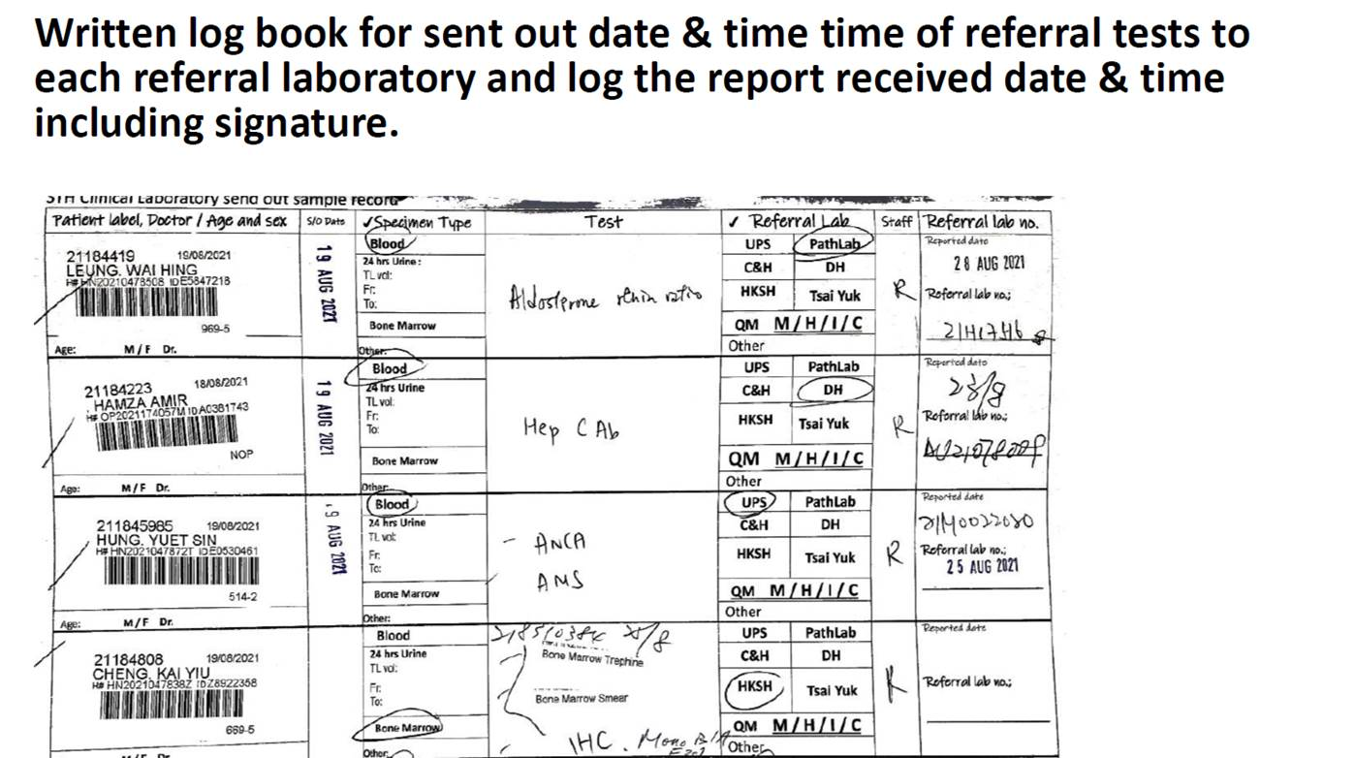
* RIS PDF Received Queue
  + Notes
    - Ensure bGenerateHL7MsgMACH7 can be run in either old(GE) or new(Mach7) method
    - Handle the case if lsContent is BLANK during the transaction of [DB to Mach7]: Mach7 new method
* LIS Enhancement Requirement - Referral Logistics
  + DB:
    - Test Level
    - Add LabOrderTestId, IsTrueCopyReceived, IsFaxReceived, IsEmailReceived
    - Ref Lab No at least 20 digits
  + Side Menu:
    - Rename “Referral Order” to “Referral Status”
  + Inquiry screen:
    - Default setting: Pending status + ALL Ref Lab
    - Add searching criteria: Test code (Ref Test only)
    - Add Output: Sample Collect Date, Test Name, Patient Name (with filter)
    - Send Out By (Mouse over Send Out DT)
    - Receive DT: Rename to “Report Received DT”, Show “Receive By” when mouse over
    - If search by LabNo, auto-select result
    - Add Export Excel & PDF Function
  + Detail Pop-up Screen:
    - Show Patient Info (Visit No, Patient No, Patient Name, Sex, DOB, Id No , ID Type Clin History), read only
    - Show Doctor Info (Ref. Doctor Name), NO need to show CC, read only
    - Show Lab Order Internal comment, read only, Highlight if not empty
    - Print Ref Label button
    - Show / Edit Remarks ( <User Code>:<Message><Line break>@<HH:mm><Line break>)
    - Show / Edit send out sample info (Send Out By, Send Out DT, “Send Out” button)
    - Show / Edit report received info (Report Received By, Report Received DT, Receive Method, Ref Lab No, “Report Received” button)
    - Show time (HH:mm) at send out DT & report receive DT
    - Add Hot Key function for remarks (REF- Internal Comment)
* Validation:

1. cannot send out if no sample collect DT
2. cannot receive report if not yet send out
3. Collect DT <= send out DT <= report receive DT

* (N/A) Referral Status Log Screen
* (LIS-485) Input Reason when Canceling Test/Order. #Test: 99001149
* (LIS-486) Log Screen for reviewing the cancel test/order activities.
* (LIS-490) Ref Label Format (Visit no, Patient ID)
* (LIS-471) Clinical History viewed by MLT only
* (LIS-353) Print location if no room & bed printed in LIS labels
* (LIS-495) Statistic Report/Referral laboratory list to Auto-complete & sort by alpha byte
* (LIS-497) Bug: When selecting a new order, the patient search does not clear the previous order information (e.g., CC doctor) before loading the patient information of another order.
* (LIS-357) Bug: Patient Search - Cannot search the record by Order doctor & Service DT #Test: PV20230200054
* (LIS-498) Add "Order Doctor" as a search criterion in the "Order Search" functionality.
* (LIS-268) Update work-group privilege will also update CreateDT and LastUpdateDT of "Workgroup" + Remove every new/create work-group functions
* (LIS-80) Show doctor detail info at "Order Search" (Icon with pop up box / Mouse over)
* (LIS-499) All search methods shall include inactive tests, profile & package because we need to find the order not to do ordering.
* (LIS-500) This part (Send Report To) must be updated together when pressing (Get Latest Patient Visit & Save/Update Patient & Save)
* (N/A) Hide Clinical History Column in patient log if no privileges
* (LIS-492) Add Alert msg box for CBC Re-Run button
* (LIS-496) Bug: Turn Around Time Statistics Not working
  + Test: EXEC usp_LIS_GET_LISRPT014 '2022-01-01', '2024-1-1', '0091A'
* Batch File for file transferring
* (LIS-507) Add Item Qty at sample management screen
* (N/A) Test/Profile/Package Setting: check duplicate code. Show warning message box
* Support Referral Status in Lab Order Items Create/Update/Delete
* (N/A) LOE Integration
  + Fill test from Request Detail
  + exec usp_LISWS_GET_HIS_Lab_Request_Detail 'LR20160100001,LR20180800001'
* Add Hotkey function to Cancel Reason
  + Use Reception Bench
    - Add new Bench Section (X2)
* Referral Test: Add an alert box for those not yet sent out